Works – 5 – Rete (Net)

Untitled (Rete)
2009
Catalytic paint on laser cut steel sheet
108 x 180 cm
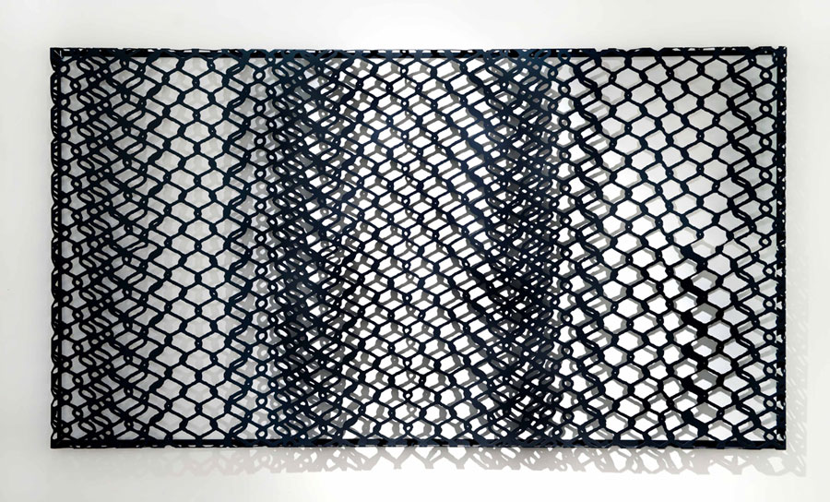

Untitled (Rete rossa)
2010
Catalytic paint on laser cut steel sheet
108 x 180 cm
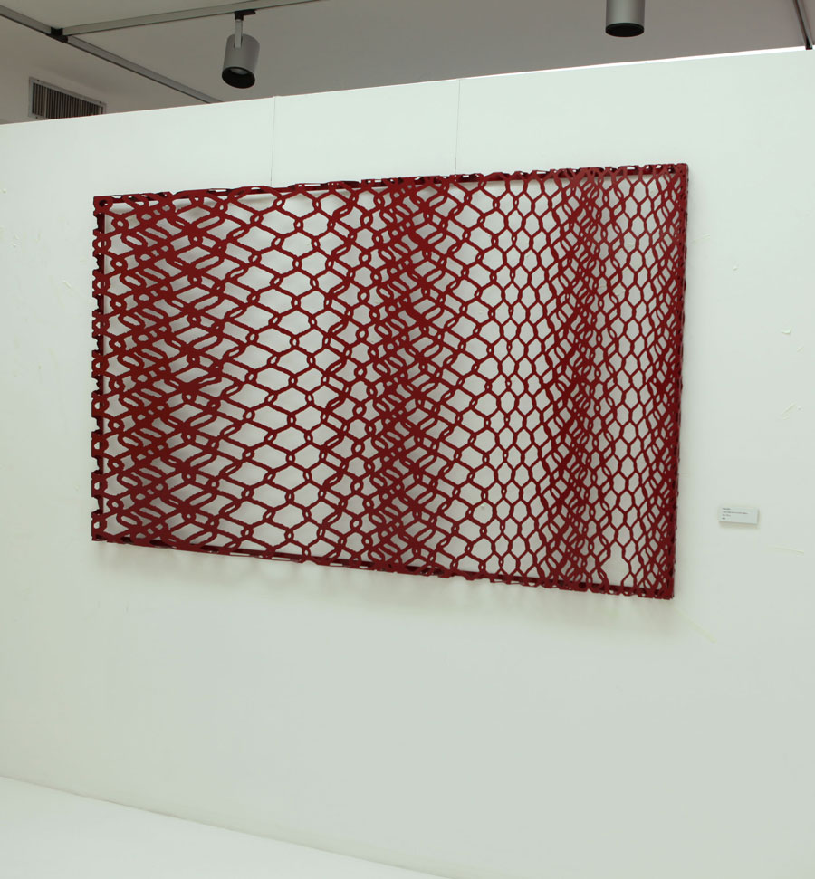

Untitled (Rete rosa)
2011
Catalytic paint on laser cut steel sheet
108 x 180 cm
Manca immagine

